**RAIDs And RISKs**

**Here are some of the issues listed, that we have faced in the way of completion of our milestones:**

We have faced many hitches, errors and issues during the building and development of this project. Also the same was troubleshot and the project building was carried forward accordingly. Here are those issues enlisted below…

* Day 1: 14th October 2022:-

1. The first issue we faced was when we were mapping user details entity to the database created in MySQL.

* Solution: This issue has been resolved by giving the user ID as the primary key in Entity, as the primary key was not defined previously.

1. Secondly, mapping the account details with the database i.e., in the database, the phone was Big-Int datatype but in the spring model class, it was of long datatype.

* Solution: The Problem was solved by changing the datatype of the phone to big-int in entity class.

1. Thirdly, The account numbers needed to be auto-generated and each of them had to be of a unique combination.

* Solution: This issue got solved by using 6 digits from the registered phone number (Big Int) and then adding it to a randomly generated 4-digit number that was also type casted from double to big int function used for addition.

a. add(b) => where a is the 6digits from phone no. and b is the random 4 digit no.

* Day 2: 17th October 2022:-

1. The only problem/issue we faced this day was, in the ng module. We did the importing part of the forms module but even after that ng module was not useable.

* Solution: The first thing was, we were unable to point out the presence of forms module, which was already installed. What actually done was, the whole folder had been deleted and then the complete installation process was started over from the beginning, this way the issue was emended.
* Day 3: 18th October 2022 :-

1. This day a small issue came up, i.e. the submit button of the login page was not working with normal click, instead it was responding only with double clicks on it.

* Solution: The issue got its solution, by passing the data using subscribe, we were sending the page id directly.

1. The last error that occurred was during the ‘finding by Id’.

* Solution: The rectification to this problem came with the exception handling when any value was not found in the database and sending an error to the request entity. Else sending the request entity .ok with the fetched value.
* Day 4: 19th October 2022 :-

1. The only issue happened this day was, the data type of phone no. was declared as big int, as a result the user details could not be found using the phone no. attribute.

* Solution: The easiest fix to this problem was, in the controller of back-end part. We used separate hql method query for big int data type.
* Day 5: 20th October 2022 :-



* Solution:

**Here is a** **histogram chart representation of the risks we have faced during the entire development/building of this project:**

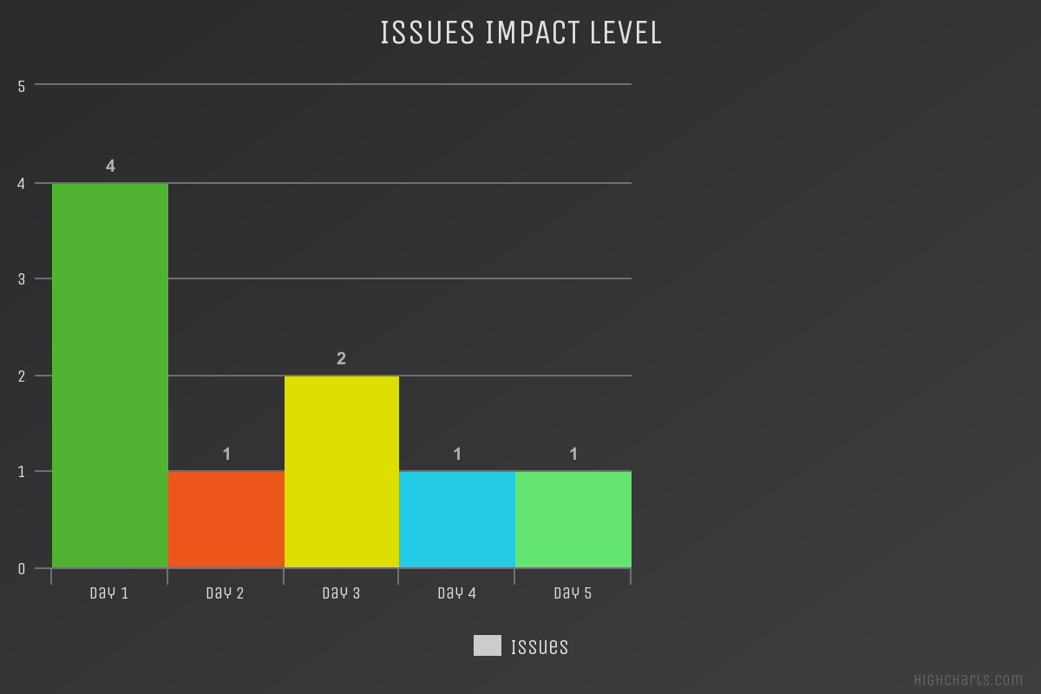

**Now, following are some of the risks of our project:**

* The users (can be admin or customer) cannot have access to online banking if you do not have an internet connection. Thus, without being online on server this web application will not work at its full.
* If the bank’s server is down, then most of the vital features of the project will not be accessible. (Exempli gratia, the user cannot be able to access his/her account, cannot transfer funds, etc.)
* User could become a victim of internet fraud, if he/she do not act in accordance with the security protocols prescribed by the bank, such as not setting strong/complex passwords or not logging out from the account after every session.
* If the user want to deposit money then he/she will have to go to the nearest bank branch in person.